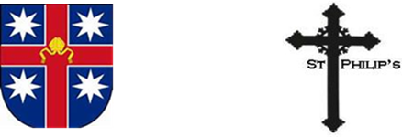St Philip’s Anglican Church

**Marmingatha Episcopate**

**Anglican Diocese of Melbourne**

*Come and Join our Diversity*

Serving the Community since 1865

**Annual Meeting Agenda**

**5th December 2021**

**At St.Philip’s Collingwood and via Zoom**

Opening Prayer

1. Apologies
2. Minutes of the 2020 annual meeting
3. Receipt of the 2021 parish electoral roll
4. Vicar’s Report
5. Warden’s Report
6. Treasurer’s report
7. Budget
8. Other Reports
9. Election of churchwardens and members of the parish council
10. Election of an auditor or independent examiner
11. Election of lay representatives to the parish incumbency committee;
12. General Business